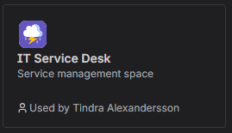
- This is the space we use to handle tickets from our co-workers.
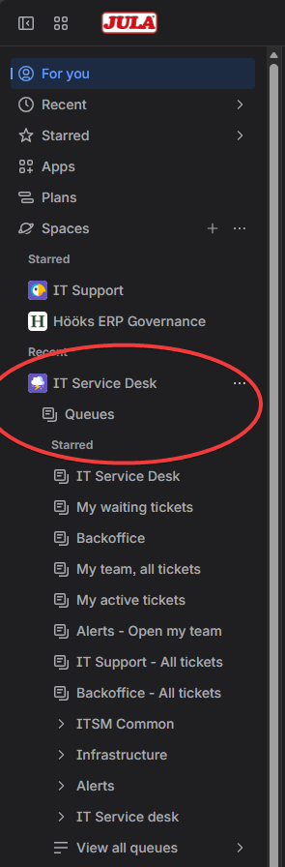
- On the left column you’ll find IT Service Desk and below you can find your queue Support-Asia. (Mine looks different because I work with other queues. So instead of IT Service Desk you will find Support-Asia and all the tickets linked with that queue)

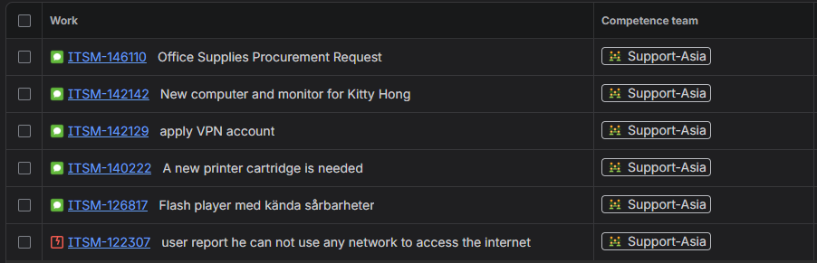
- When you click on your queue you will see all of your tickets.

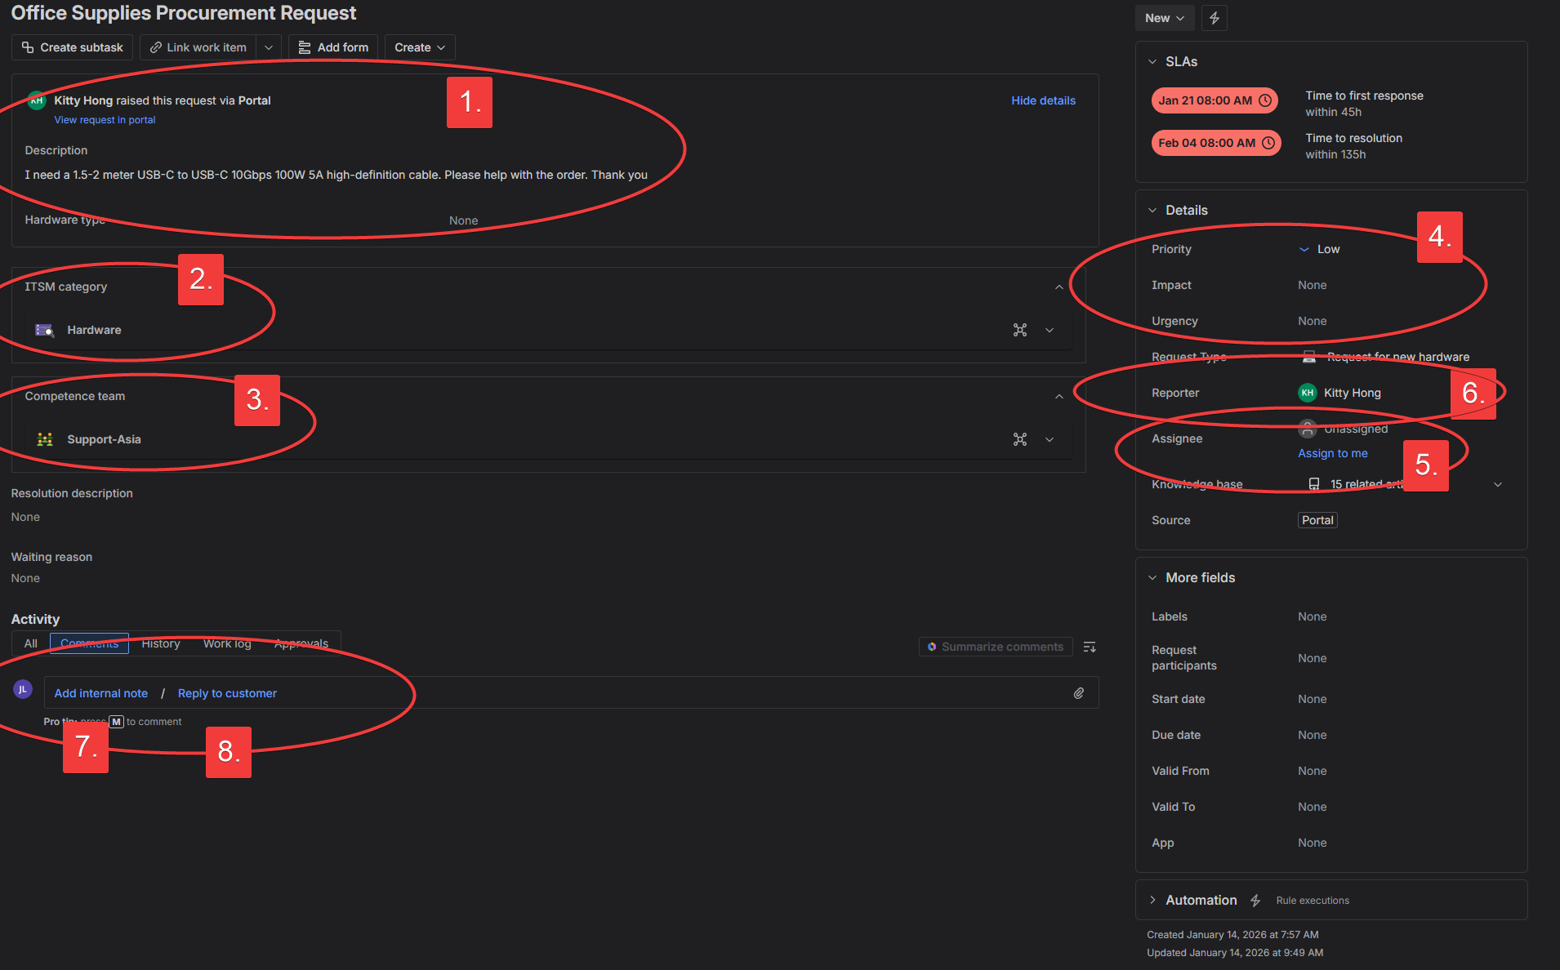
- You click on the tickets and now there is a few things you need to know. First, we will look at a ticket that someone else has sent in using email or our IT-portal.

4.1 This is the description where the reporter describes what they need help with.
4.2 This is where we categories what the ticket is regarding. We have a lot of categories and chose one that is fitting for the ticket. E.g “Network” if there is something wrong with the network etc
4.3 Competens team defins where the ticket is handled. Your team is always Support-Asia and should never be changed unless you need help from us. Then please change it to “IT service desk”.
4.4 You prioritise the ticket and use Impact and Urgency, the ticket-system will help you define if it is a Low, Medium or High ticket.
Impact = How many are affected by this issue or request
Urgency = How fast does it need to be resolved
Combine these two but never put high priority on both of them, that will create a major incident and unless the whole office if affected by an issue; this should never be used.
4.5 Always assigne yourself to a ticket that you are working on. You can use the quick-button “assigne to me”.
4.6 Reporter should always be the user who needs help, no one else.
4.7 If you “Add internal note” the reporter will not see it. This is used to log your progress in the ticket or communicate with another tecnichian and not the user.
4.8 To communicate with the reporter, if you need more information regarding the ticket or to confirm that the issue is resolved, use “Reply to customer”.

If you are waiting for a reply from the user, please change the Status at the top right corner of the ticket to “Waiting for customer”. And when a ticket is resolved, please change it to “Resolve”. When you do, this will appear
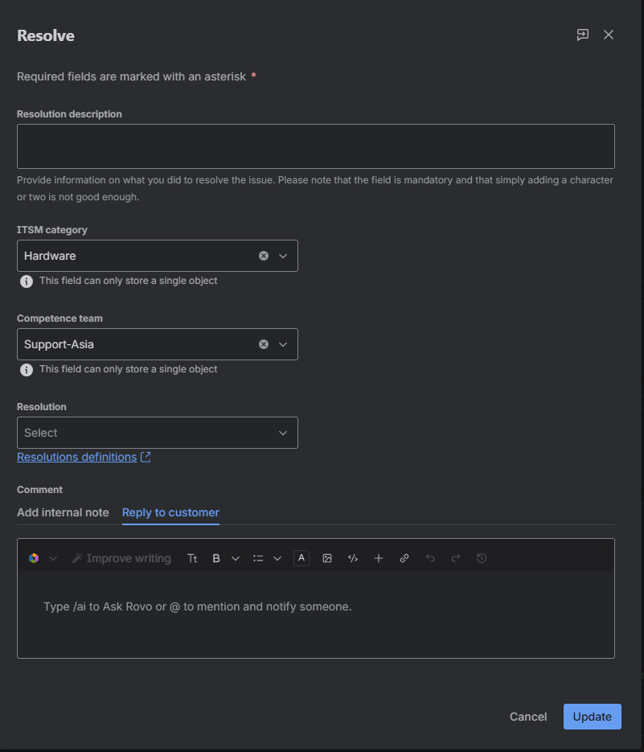
Please insure that all the information is correct before proceeding.

If you get a phonecall or someone at the site needs assistance, you can create a ticket for them using the + Create button at the top of the page (in the middle).
  - The space should always be IT Service Desk (ITSM). You do not need to change this!
  - If someone needs help with access or have a question, please chose [System] Service Request – and below (1.3) you can chose what kind of help the user needs. Access, hardware or just a general request.
If someone has an issue; “something that worked yesterday dosnt work today” it is an Incident. Please chose that one. And under type (1.3) you can chose Incident (not much else to put in there).
  - This will always have your name from the start, you need to change it to the user your helping.
  - Here you put in as much information as you can regarding the ticket. We don’t have a standard, but as much information as possible.
  - And then you click create, the ticket information appears in the bottom left corner. Click View Ticket and you can start working on it.
  - 